Special lunch！ Rice by wood fire and natural mushroom soup
Rice plant
crop tour
with
local people.
We will have the lunch under the blue sky.☀ We will prepare new rice which will be dried naturally under the sun.

Great skill!～Tie and construct a
dryging shelf for the rice plants～
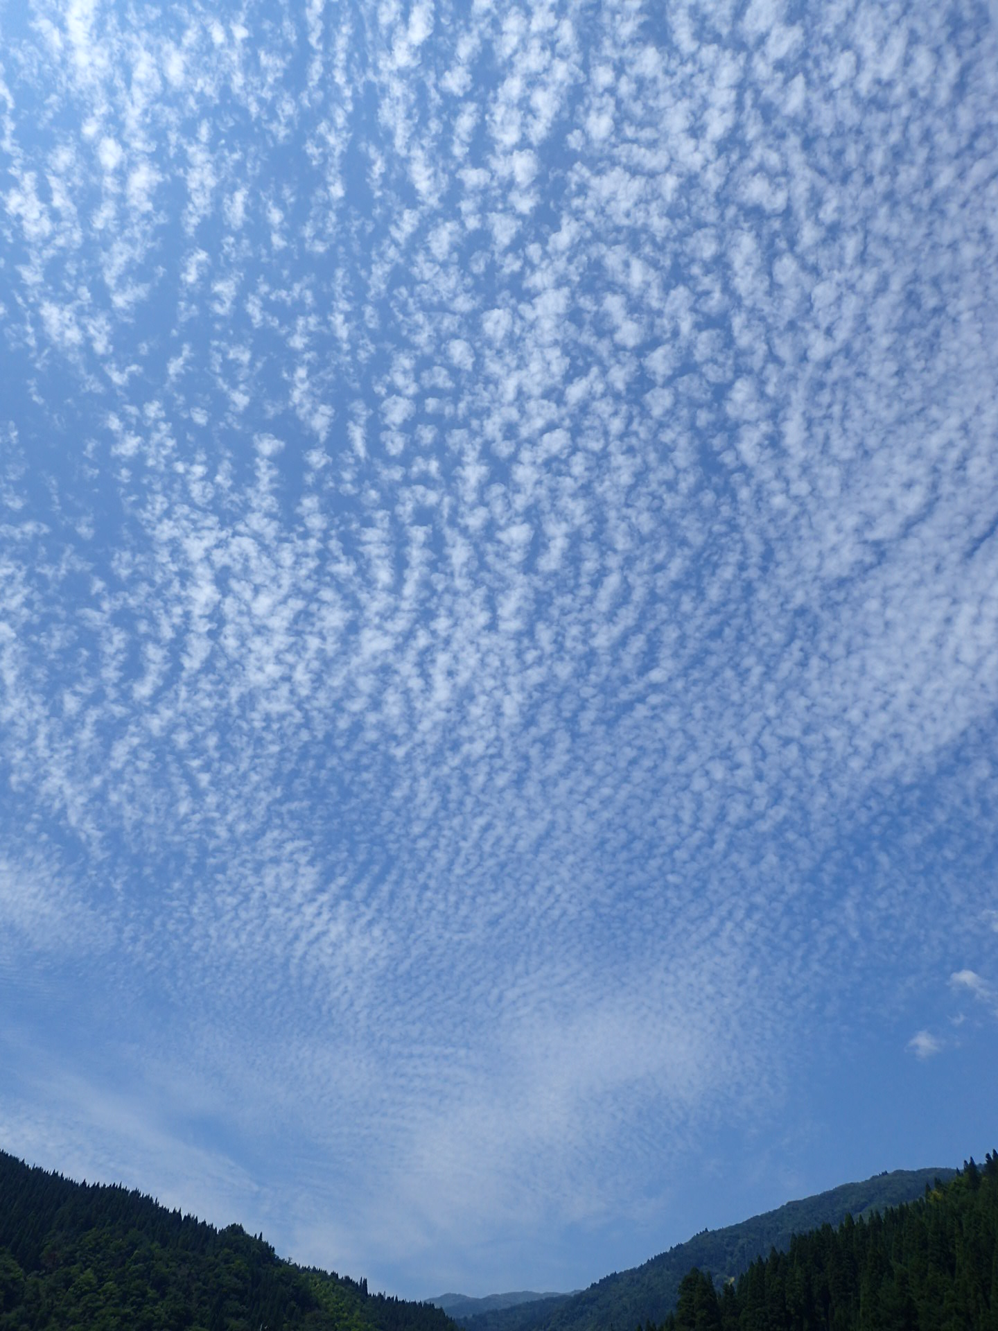
Let’s try to make drying shelf.
We will construct drying shelf with natural wood branches called “Neso” in the Hida region. The technique is not commonly used now, however, it is a traditional skill used to tightly tie the wood shells under the natural roof of “Gasshou-House” in Shirakawa-go, World cultural heritage.

You can have good experience harvesting and drying a rice plant crop.
Date
2015 10/11(sun)
start10:00～11:00
～15:30

Place
Yamada Kamioka-cho Hida-city.
You can access here to take Nouhi-bus, leave Takayama-station at 9:40 or Furukawa-station at 10:20,
and get off Nagareha-snow ground. We will be waiting for you at the Bus-stop on 10:45.

This way makes good tasting rice since it is dried by sunshine. It takes much more time(1 to 2 weeks) than using a drying machine.
We will send you the rice (2kg) after that. And you can enjoy the rice in your home！
Fee: 6,000yen/adult 5,000yen/ elementary school student or younger (cost、lunch、gift(rice)）
Reservation: Let me know your name, address, gender and your cell phone numbers of all of the applying members. After that we will call you about the tour.
NPO Hida-shi Shirakawa-go Nature Guides Asociation
223-1Tunogawa Kawai-cho Hida-city 〒509-4301
Tel. ０９０－７６７９－０７９３ Fax ０５７７－６５－２２１１
E-mail sizenannai@hida-catv.jp

NPO法人飛騨市・白川郷自然案内人協会
電話・ファックス

Photo image
